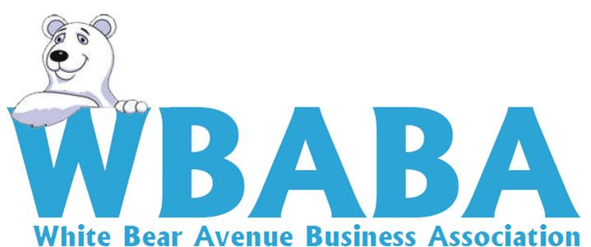

Board & General Membership Online Meeting
11/18/2022

In Attendance:, Joe Fox, Lisa Theis, Rich Dunn, Paul Skytte, & Laurie Siever, Marv Koppen

BOARD MEETING

Agenda: Motion by Siever, second by Fox to accept the agenda.

Minutes: Motion by Siever, second by Fox to accept the minutes

Adjourn: Motion by Siever, second by Koppen to adjourn Board Meeting

MEMBERSHIP MEETING

Agenda: Motion by Siever, second by Koppen to approve the agenda.

Minutes: Motion by Fox, second by Koppen to accept the minutes

Charitable Gambling Report: Motion by Siever, second by Koppen.

Upcoming Events: Movie nights 2/23, 4/20, 8/17 and 11/3 and Kite Fly-5/6 Taste of the East Side 5/13.

Adjourn: Motion by Siever, second by Fox.

